React Context and Hooks lesson 2

What is context API



With the react context API share state don’t have to pass props around .  
Hooks can do stuff in functional components that previously could only do inside class components - like use state or tap into a lifecycle metond

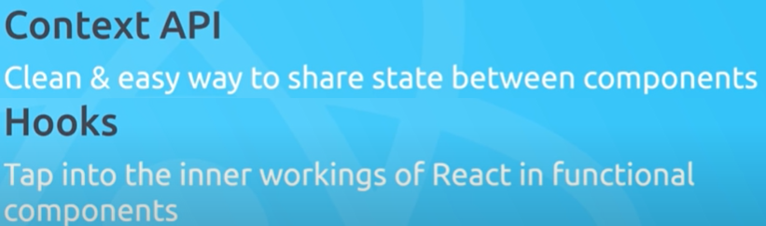

Using together can work with shared data inside app similar to redux without having the lift of redux

